O-List Ecommerce - Analytical Report & Conclusion

### **VISUALIZATION**

We have concluded the analytics on the Telecom Churn dataset as below

1. By **hypothetically deriving the insightful graphs**
2. By Providing **Recommendations on the analyzed dataset**
3. **Hypothetically deriving the insightful graphs**

To draw the insightful graphs it is considered that, after Data analysis and Feature Engineering, the Customer Reviews are finally segregated into two main Categories

* **Positive Reviews** – where Review score is equal or greater than 3
* **Negative Reviews** – where Review score is less than 3

1. **Reviews given by the customers**

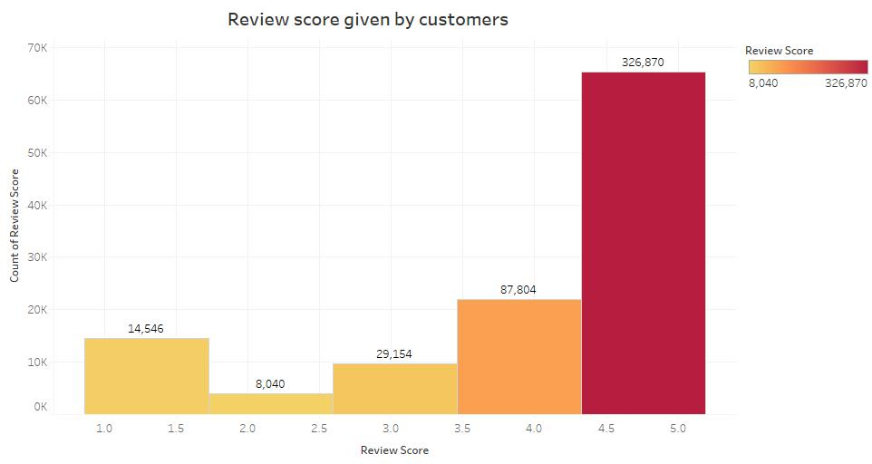

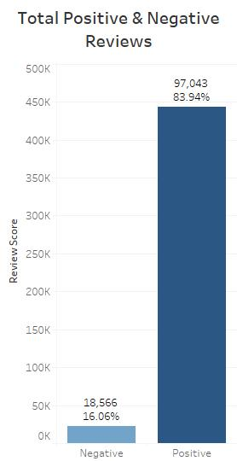

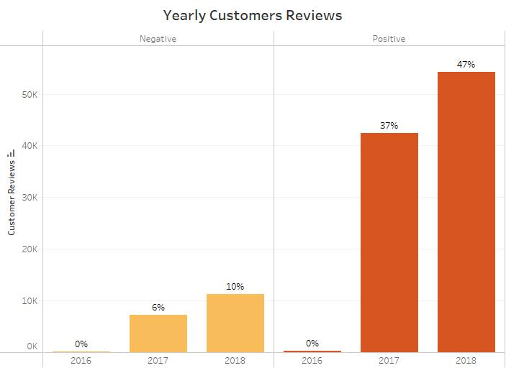

As per the above graphs

– **Review score given by customer**

– **Total Positive and Negative reviews**

– **Yearly customer reviews**

The following observation can be made

* Maximum of the customers gave a review score of 4 or 5
* From the total review score given by the customer 84% of it is Positive i.e. a review score more than 3
* Considering the review it can be seen that Positive reviews have increased by 10%

1. **Geolocation of the customers**

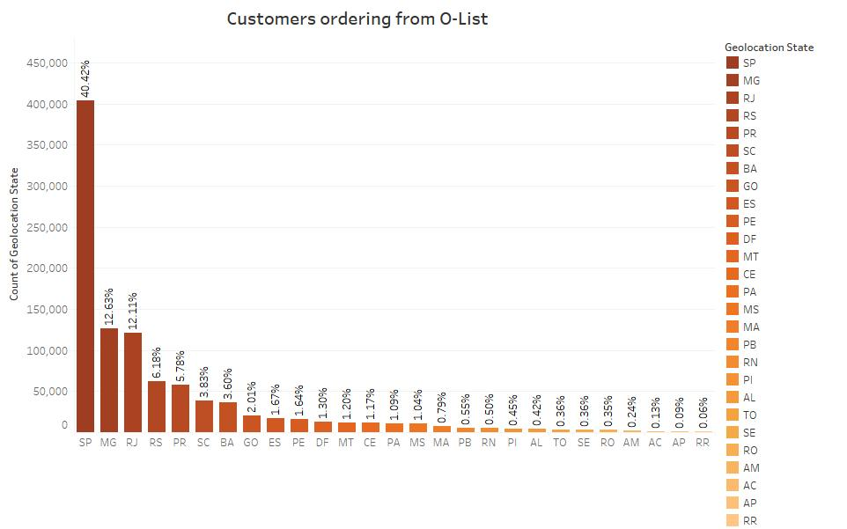

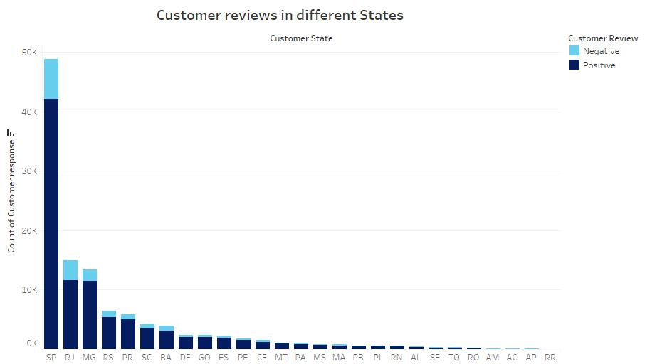

As per above graphs:

– **Customers ordering from O-List**

– **Customer reviews in different states**

The following observations are made

* The top three states customers are using O-List to shop online are Sao Paulo, Minas Gerais and Rio de Janeiro
* From the graph its evident that all the customers ordering from O-List have given more positive reviews to the products
* The top 3 positive reviews are given by customers staying in Sao Paulo, Rio de Janeiro and Minas Gerais i.e. 36.41%, 10.07 and 9.92% respectively.

1. **Sellers on O-List**

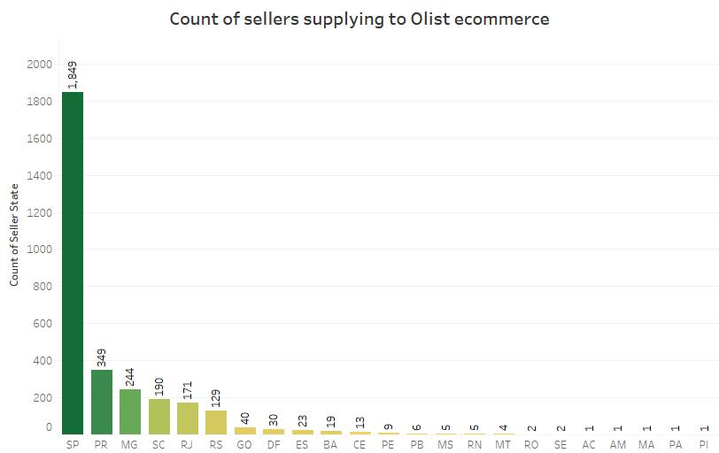

As per the above graph:

– **Count of sellers supplying to O-List**

The following observations are made

* The major sellers using O-List as their platform are from Sao Paulo, Parana, Minas Gerais and Santa Catarina.
* The count of sellers is shown in the bar graph which shows that Sao Paulo has 1849, Parana has 349, Minas Gerais has 244 and Santa Catarina has 190 sellers.

1. **Payment methods used on O-List**

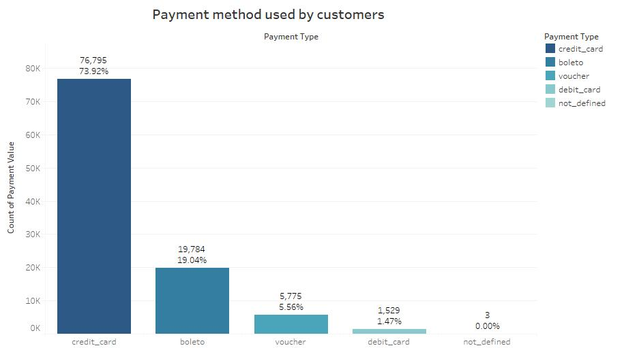

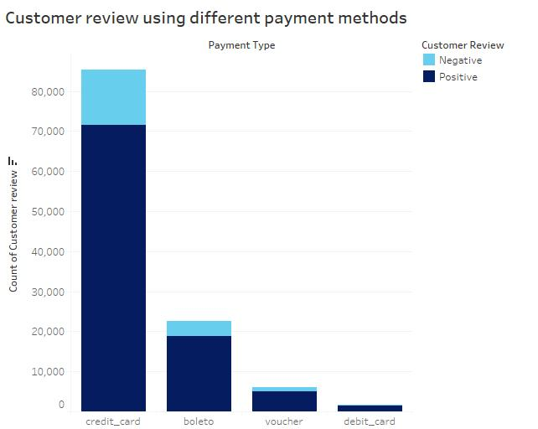

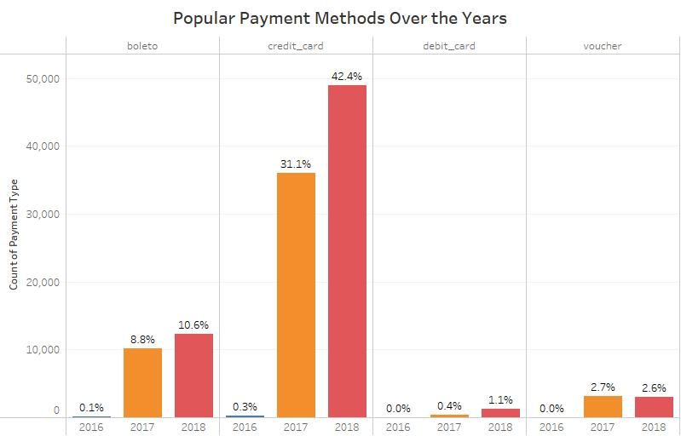

Note: **Baleto** simply refers to Ticket in English. It is a payment method in Brazil regulated by FEBRABAN, short for Brazilian Federation of Banks. It can be paid at ATMs, branch facilities and internet banking of any Bank, Post Office, Lottery Agent and some supermarkets until its due date.

As per above graphs:

– **Reviews given by customers using different payment methods**

– **Popular payment methods used by the customer**

The following observations are made

* In all the three year customer used Credit card while making payment and the second most payment method is Boleto
* The percentage of each mode of payment is shown in bar graph which shows amongst all payments made by customer the credit card is used by 74% of the customers, Boleto is used by 19% of the customer and 7% of the user used Voucher and Debit card.
* We can observe from the stacked plot that most of the customers used credit card have given positive reviews. Also, for the Boleto, Voucher and Debit card user it is same.

1. **Products ordered by the customers on O-List**

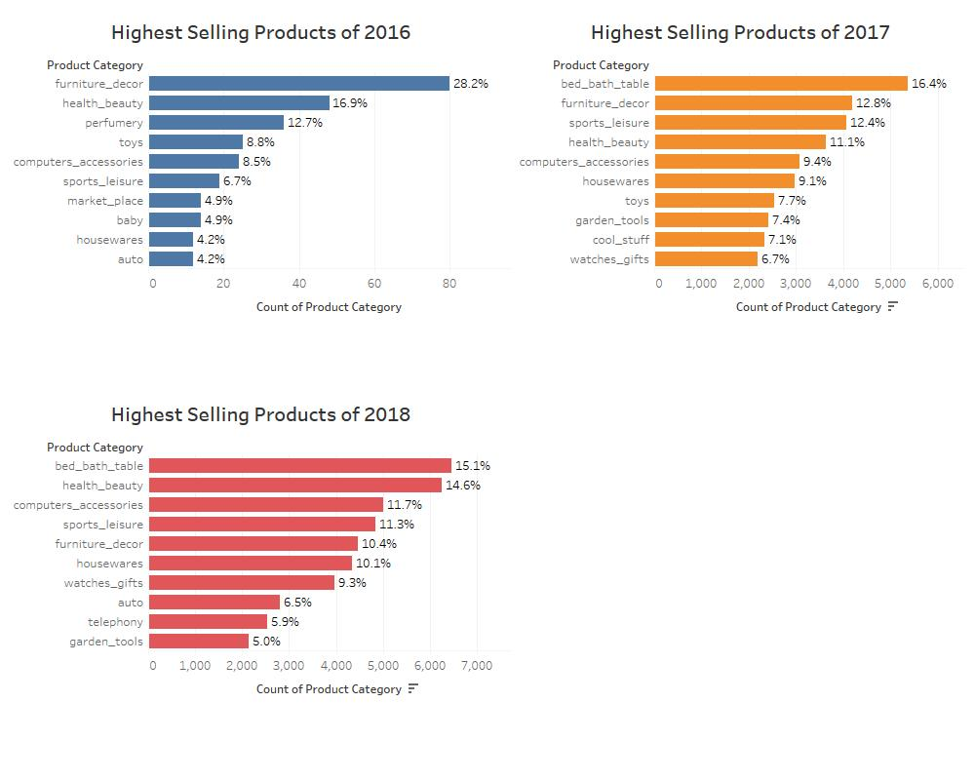

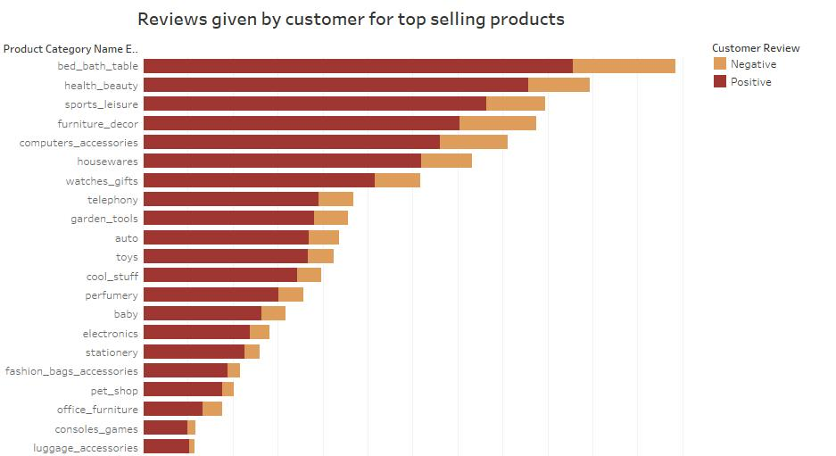

As per above graphs:

– **Top selling products in 2016, 2017 & 2018**

– **Reviews given by customers for the top selling products**

The following observations are made

* The most ordered product in 2016 is furniture_decor, in 2017 and 2018 is bed_bath_table category. The least ordered product is security_services.
* The number of products ordered in 2016 is much less than products ordered in 2017 & 2018.
* From the stacked plot we can conclude that most of the reviews for product category bed_bath_table are positive and it is the same for other product categories as well.

1. **Logistics of O-List**

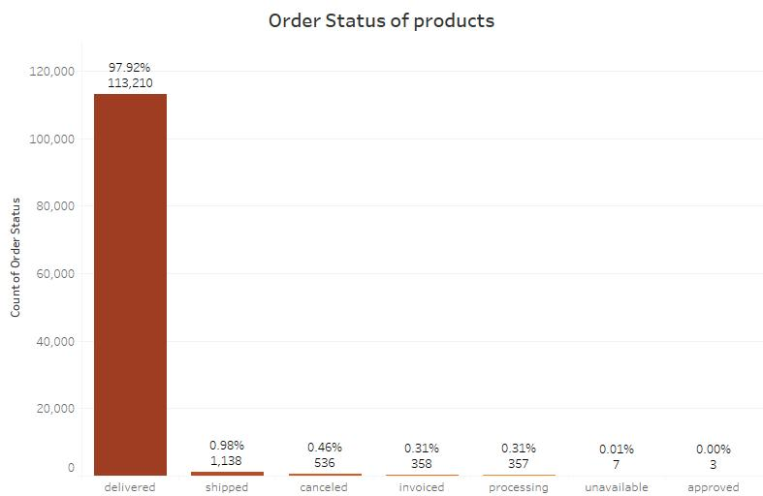

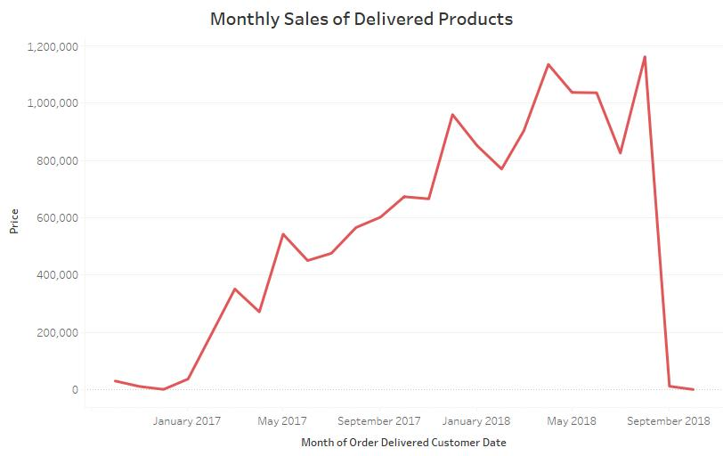

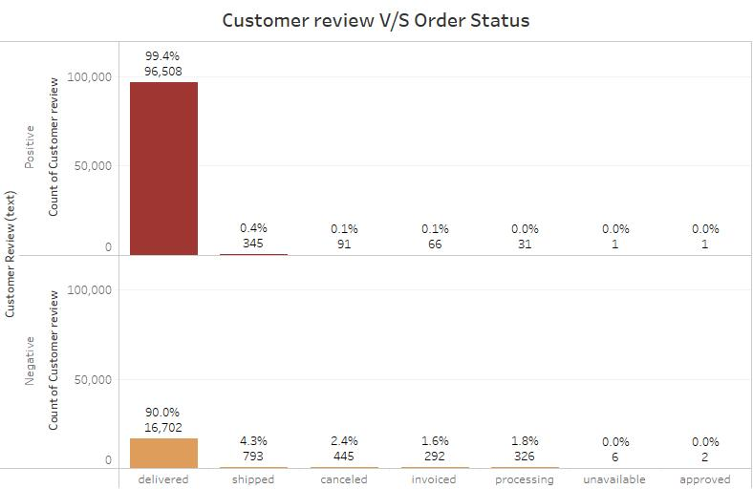

As per above graphs:

– **Order status of products**

– **Monthly sales of delivered products**

– **Reviews given by customers for the order status of products**

The following observations are made

* Out of all the orders placed maximum of them are efficiently delivered to the customers. 98% products are delivered
* The monthly sales has increased from October 2016 to August 2018 (highest) and then decreases for a short span
* The delivered products received 99.4% positive customer reviews whereas the non-delivered products received more of negative reviews i.e. 10%

1. **Conclusion & Recommendations**

* The overall review score given by customers showed that most of the customers are very happy and satisfied with the products and there delivery.
* As the customers are from Sao Paulo, Rio de Janeiro and Minas Gerais, to increase or retain these customers’ creative marketing strategies should be implemented like opening up Pop-up shops, posters or banners or O-List on highways or busy streets.
* Maximum customers preferred to pay through Credit cards. Some customer reward benefits or discounts will make them to give a better review score.
* Maximum number of sellers are either in the same state as the customer or in the nearby states. An awareness about O-List online store should be created among sellers of other states so as to increase the number of customers using the platform.
* O-List Company was launched in the year 2015. Therefore, in 2016 it was still new in market but gained its peak popularity in 2017 and 2018 by making a profit of around 1,162,133 Brazilian currency. After which a dip is observed.
* Bed, bath and table category is the most popular products from which people ordered in O-List. To improve the selling of other category a survey should be conducted among customers to know their style and fondness related to products.